NAME:PAREENITA A.SHIRSATH PRN:221101062 ROLL.NO:57 T.E.A.I.&.D.S.

**SBL-CC EXPERIMENT NO : 4**

IMPLEMENTATION:

STEP 1:- In AWS,Services->Storage->S3.

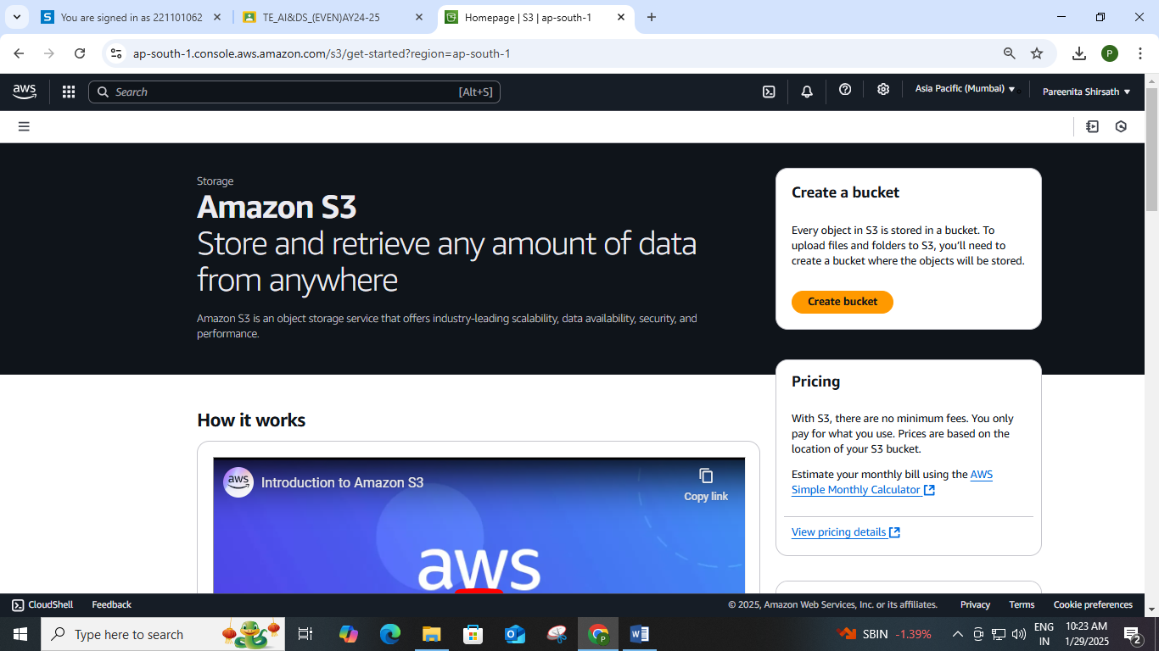

STEP 2:-Create Bucket,Name It And Select Aws Region.

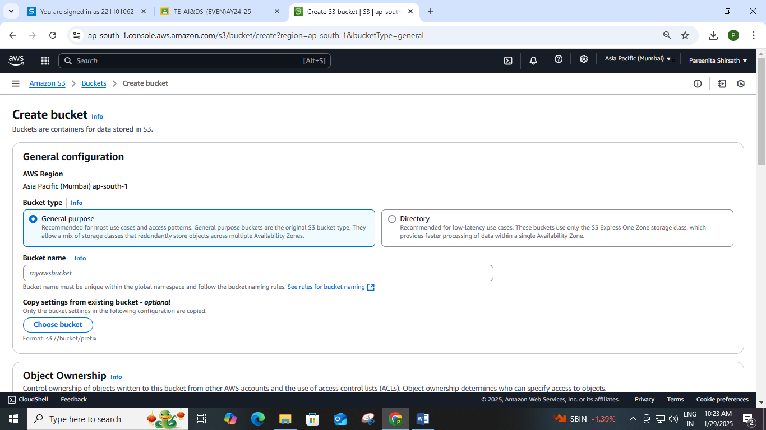

STEP 3:-Bucket “Achufirst” Is Created.

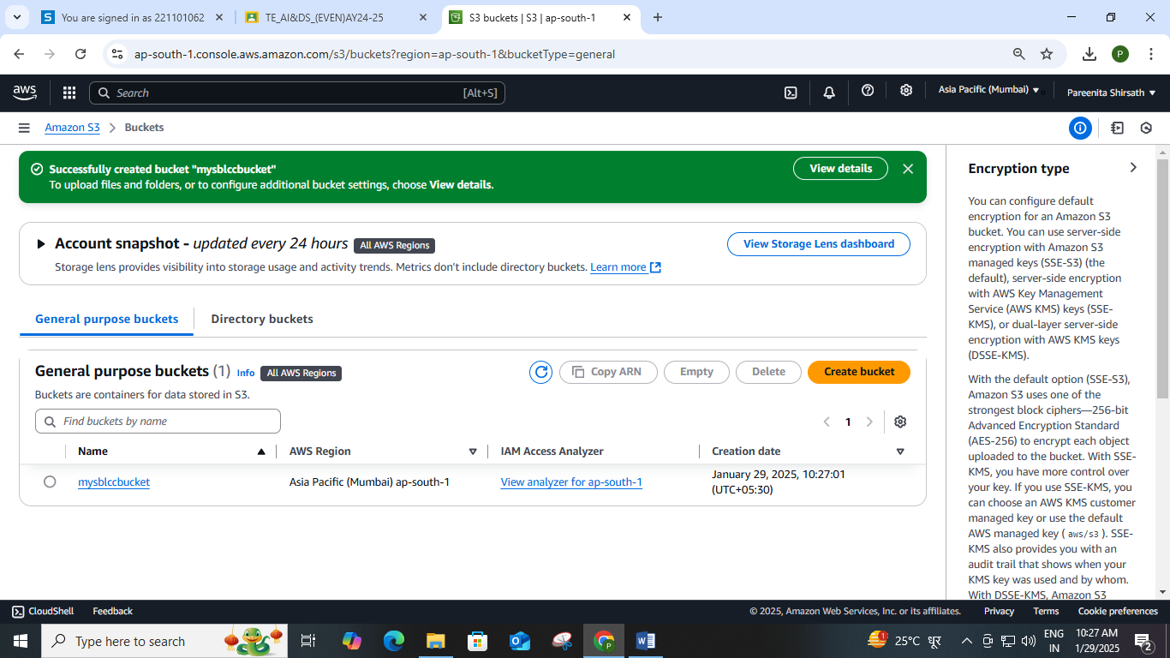

STEP 4:-Upload Files Successfully.

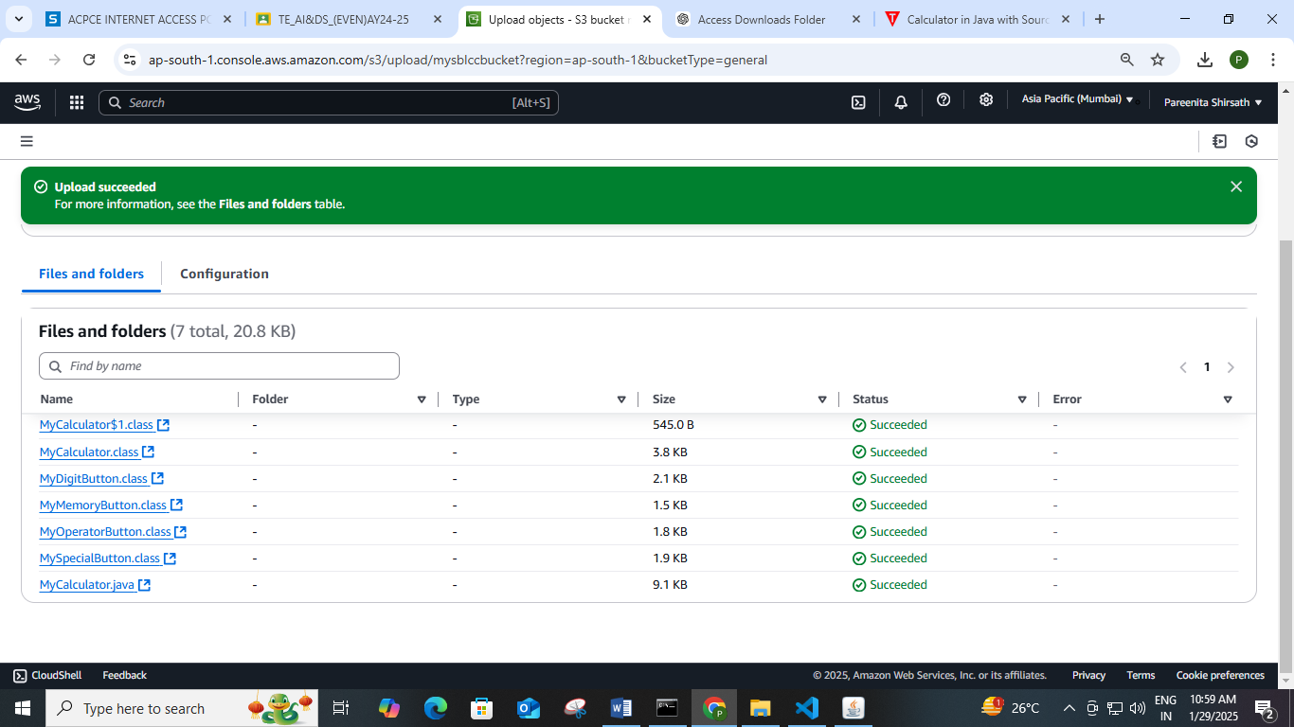

STEP 5:-Copying Arn For “Achufirst”.

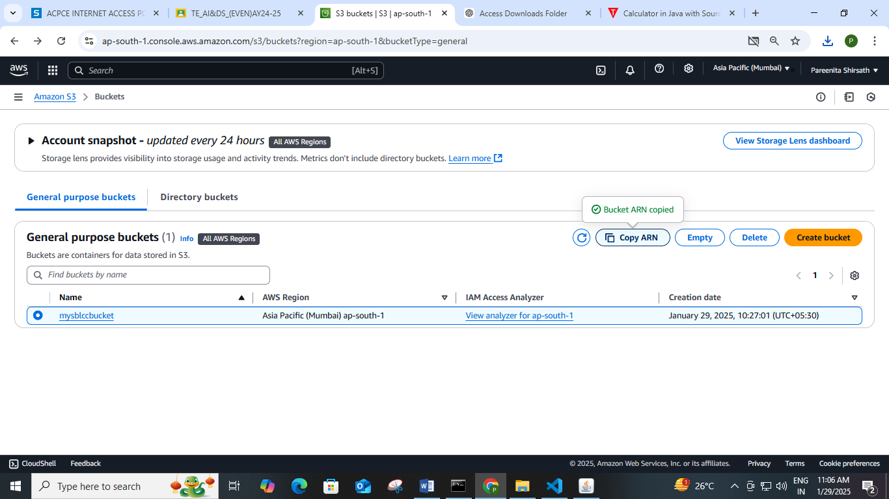

STEP 6:-Going To Permissions->Edit Bucket Policy->Ploicy Generator->Do As Shown.

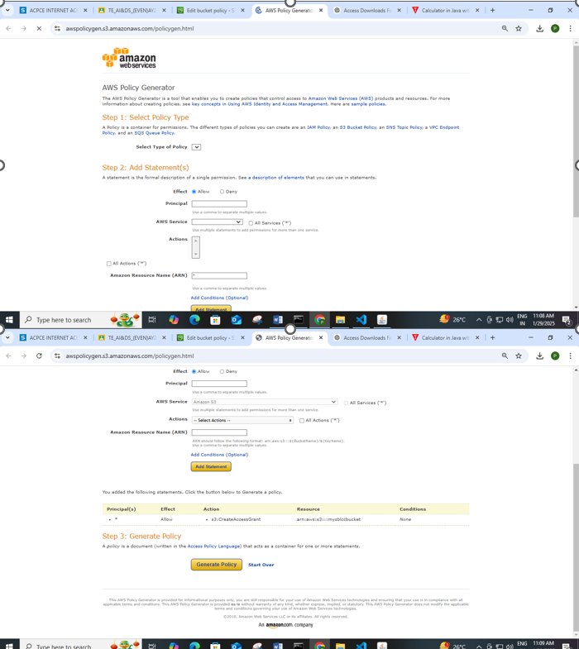

STEP 7:-Successfully Edited Bucket Policy.

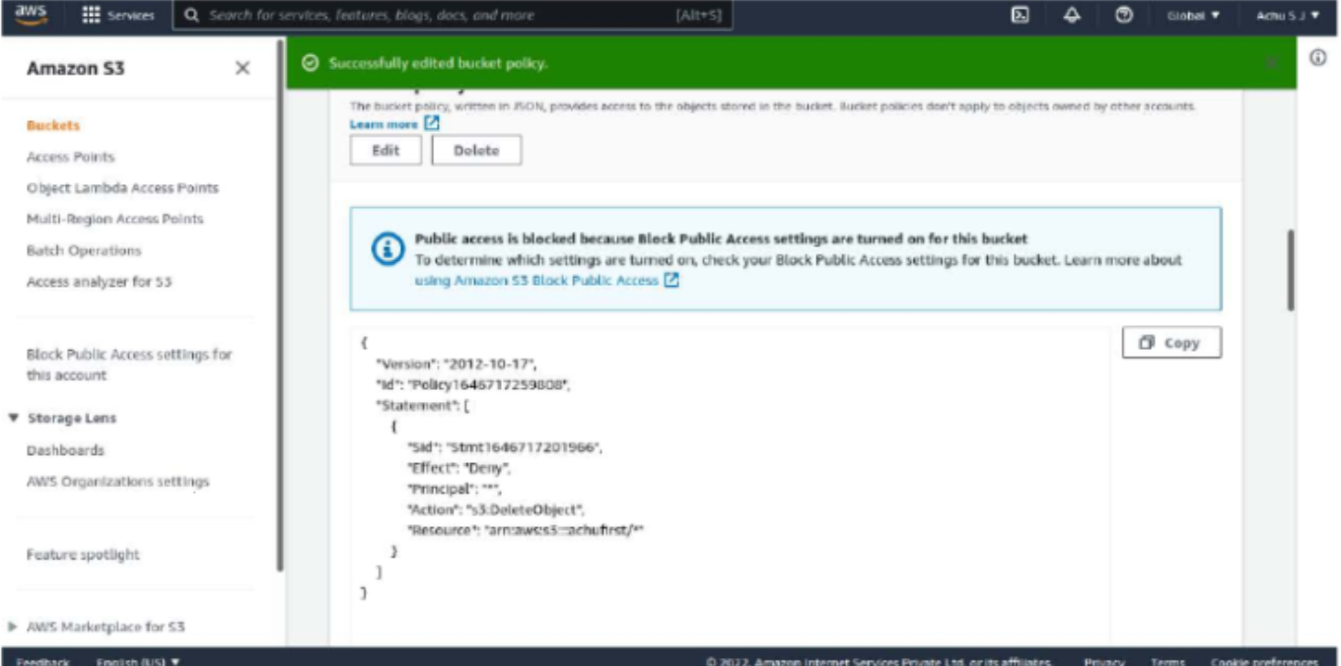

STEP 8:-Empty Bucket Successfully.

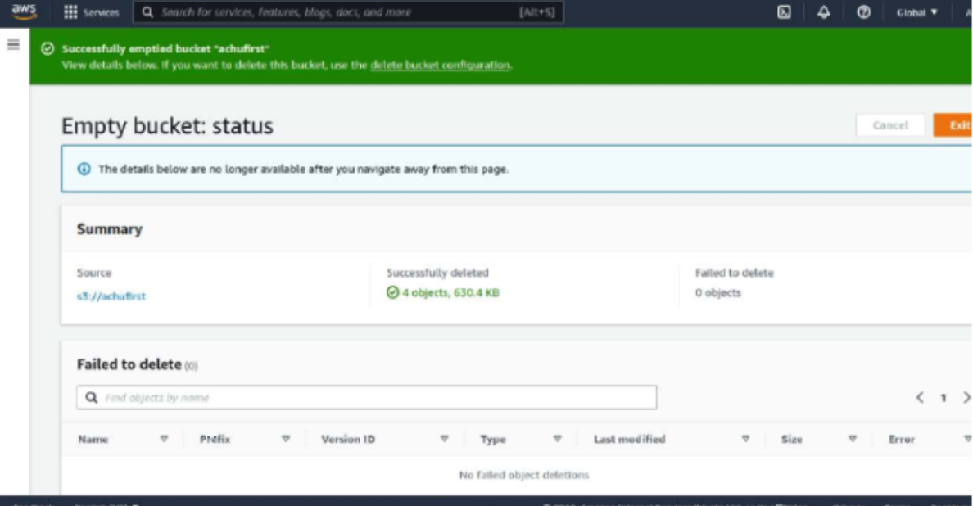

STEP 9:-Successfully Delete The Bucket.

